
FRTB DEFAULT RISK CHARGE · SECURITISATION (NON-CTP)
Two Maturity Rules for
Securitisations
Where Default Risk Ends and
Migration Risk Begins

Methodology Note · The MAR22.30 / MAR22.34(1) split, and how CSR-Sec picks up what DRC deliberately skips
Prepared by · Market Risk — FRTB Programme
Date · 29 May 2026
Reference portfolio · v5 · Engine · drc_securitisation + capital_main

Contents
1. Executive Summary
2. The Trap — Why Many Practitioners Miss This
3. Two Distinct Maturity Rules, Side by Side
4. The Regulator's Two-Component Design
5. Default Risk Capital — Capped at 1Y by Design
6. Migration Risk Capital — Picked Up by CSR-Sec
7. Shape — How Each Block Responds to M(T)
8. Conclusions
Appendix A — Engine Implementation Map
Appendix B — Reconciliation Arithmetic
References

1. Executive Summary
In the FRTB framework a securitisation position is touched by two different maturity rules at the same time, and they do almost-opposite things. The rule that lives inside the risk-weight formula fixes the maturity at one year for every tranche, regardless of how long the tranche actually has to run. The rule that lives at the jump-to-default position pre-netting takes the position's *actual* remaining maturity and uses it to scale the gross JTD down if the position has less than a year to run. The two rules are not in conflict — they exist precisely so that the default risk of the position is captured cleanly in one capital block (DRC) while its credit migration risk is captured separately in another (CSR-Sec).
KEY MESSAGE Inside the securitisation risk-weight machinery, the maturity component is deliberately suppressed — every tranche is calculated as if it were a one-year exposure. This is not an approximation or an error; it is the framework saying *default risk over the next 12 months* is what the DRC block is for, and *spread / migration risk over the position's life* is what the credit-spread block is for. Mix the two and you double-count.
The practitioner's instinct — that a five-year AAA tranche must somehow attract more capital than a one-year AAA tranche on the same pool — is right. The extra risk is real. It just doesn't live in DRC. It lives in CSR-Sec, and it gets there mechanically through the credit-spread sensitivity (CS01) at the longer tenor pillars, where modified duration is larger and the per-pillar risk weight has been calibrated to embed migration shocks. The note below makes the split explicit, ties it to the exact paragraphs of the BIS framework, and reconciles it line by line with the engine's implementation.
2. The Trap — Why Many Practitioners Miss This
A reasonable reading of the standardised ratings-based table for securitisations notices that it has separate columns for one-year and five-year maturities, with linear interpolation in between. A reasonable person then expects a five-year AAA senior to attract a higher risk weight than a one-year AAA senior on the same pool — and so a higher capital number. That intuition is right for the banking book and wrong for the trading book.
The reason is buried in a single short paragraph of the trading-book DRC chapter, which says — in plain words — *use the banking-book sec risk-weight machinery, but set the maturity input to one year for every tranche*. The 1-year and 5-year columns of the ratings table do not get interpolated; the 1-year column is always picked. The maturity sensitivity of the banking-book formula is silenced.
Without context this looks broken. With context — that the trading book splits credit risk into a default block and a spread block — it is exactly right. The spread block has its own maturity sensitivity through CS01 at the longer pillars. Counting maturity in the DRC formula as well would double-charge for the same risk. The trap, then, is to assume that the two paragraphs (the one that pins the RW to 1Y, and the one that scales JTD if the position is under a year) describe the *same* maturity concept. They do not.
3. Two Distinct Maturity Rules, Side by Side
The trading-book DRC framework applies two maturity rules to every securitisation position, and the two are independent of each other. The table below contrasts them; the rest of the note builds on the distinction.
Dimension | M(T) inside the RW formula | M(T) at JTD scaling, pre-netting
Source | MAR22.34(1) — the trading-book DRC overlay | MAR22.30, importing MAR22.15-18 into sec
Where it is applied | Inside the banking-book RW machinery (CRE40-44): the ERBA 1Y/5Y table interpolation; the IRBA supervisory parameter p in CRE44.17 | On per-position GROSS JTD, before per-tranche netting
The actual value used | Forced to 1.0 year — the position's real maturity is IGNORED here | The position's REAL remaining maturity, clipped to [0.25, 1.0]
What this captures | Pure 1-year default risk on the position | The reduced default exposure of sub-1Y positions (less time at risk)
Effect on a 5Y senior vs a 1Y senior, same pool | Identical RW (both at the 1Y column of the ERBA table) | Identical scaling factor (both = 1.0; cap binds for both)
Effect on a 6-month senior vs a 5Y senior | Identical RW (still both at the 1Y column) | Scaling factor 0.5 vs 1.0 — the 6-month position's JTD halves
What is intentionally NOT captured here | Migration / spread-widening over the position's life | Any default-risk differentiation between a 1Y and a 5Y position
Exhibit 1. The two M(T) rules. The first pins the RW machinery to a one-year horizon; the second scales JTD down only for positions with less than a year to run. Neither captures the multi-year migration differentiation — that is what the credit-spread block is for.
MNEMONIC Two M(T)s, two jobs, no overlap. The RW M(T) is the regulator saying *default risk = 1-year default risk, full stop*. The JTD scaling M(T) is the regulator saying *if you only own this position for a few months, you have less time to be defaulted on*. Both rules face the same direction (towards 1 year), but they refer to different things and co-exist by design.
4. The Regulator's Two-Component Design
The reason the two rules can co-exist without conflict is that the trading-book framework has already decided where each kind of credit risk lives. Default risk and credit-spread (migration) risk are allocated to two different capital blocks, and the maturity treatment in each block is tailored to what that block is supposed to capture.
Risk component | Capital block | Maturity treatment in that block
Default risk during the holding period — i.e. the issuer or pool actually defaults | DRC (this engine, MAR22.33-35 + CRE40-45) | RW pinned to 1Y by MAR22.34(1); JTD scaled down for sub-1Y by MAR22.30 (≈ MAR22.15-18)
Migration / spread-widening risk — credit quality deteriorates without an actual default event | CSR-Sec (Phase 2 of `capital_main.py`, MAR21) | Full position maturity used, via the FRTB tenor pillars at 0.5/1/3/5/10Y; CS01 captures duration-times-spread; bucket RWs are calibrated on historical spread moves that include migration jumps
Exhibit 2. Credit-risk capital under FRTB lives in two blocks. The maturity treatment in each block is designed for the risk that block captures; the two together cover the position's full credit-risk profile.
The MAR22.34(1) overlay text states the design intent explicitly: the maturity component of the banking-book formula is set to zero (a one-year horizon is assumed) specifically to avoid double-counting with the migration-risk capital that CSR-Sec is going to apply. Read the two rules together and the framework is consistent; read either rule in isolation and it looks broken.
5. Default Risk Capital — Capped at 1Y by Design
Inside DRC sec, the position's actual remaining maturity affects capital through the gross-JTD scaling factor and nothing else. That factor clips the maturity into the interval [0.25, 1.0]: a position with more than a year to run gets a factor of 1.0 (no reduction), a six-month position gets 0.5, a three-month or shorter position gets the 0.25 floor.
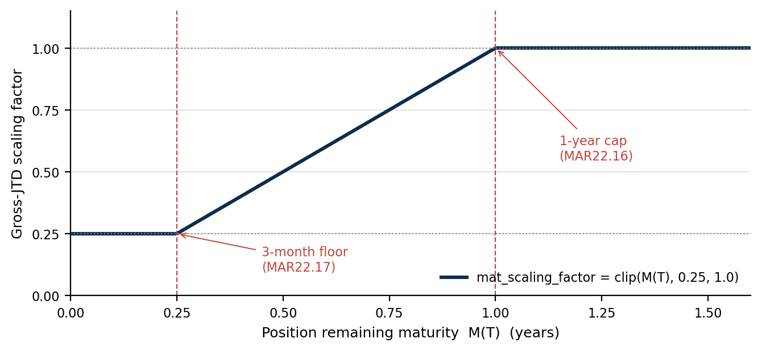
Exhibit 3. The MAR22.30 / MAR22.16-17 scaling factor as a function of the position's remaining maturity. Floor at three months, cap at one year. The position's real M(T) is used here — unlike the RW formula, which is pinned to 1Y.
Under this rule a five-year AAA senior and a one-year AAA senior on the same pool produce identical DRC capital. Both have a scaling factor of 1.0; both have an RW that comes out of the same 1-year column of the ERBA table. The 5Y position is not getting away with less default capital than it should — the framework has decided that *default capital looks at a one-year horizon*, and either position is fully exposed to a default in the next twelve months. The 5Y position's additional credit risk over *years two through five* is not a default-risk question; it is a spread-and-migration question, captured elsewhere.
6. Migration Risk Capital — Picked Up by CSR-Sec
The CSR-Sec block charges capital against credit-spread sensitivity at the FRTB tenor pillars (0.5Y, 1Y, 3Y, 5Y, 10Y). For a securitisation tranche the cash-flow profile determines which pillars receive non-trivial CS01: a five-year senior has its CS01 concentrated at the 3Y/5Y pillars; a one-year senior has it at the 0.5Y/1Y pillars and approximately zero further out. Two mechanisms then conspire to give the longer-tenor position more capital:
- Larger CS01 magnitudes at the longer pillars. Modified duration is longer for a five-year position, so the price impact of a 1bp spread move is mechanically bigger. A five-year AAA senior produces a meaningful CS01_5Y; a one-year position produces almost none.
- Bucket risk weights pre-embed migration. The CSR-Sec risk weights in MAR21 are calibrated from historical credit-spread moves at a one-year horizon, 97.5% confidence. Those historical moves include not only smooth-rating volatility but the discrete jumps observed when ratings migrate. So the RW per basis point of CS01 already pays for migration.
There is a third, smaller effect through vega and curvature: tranches with embedded optionality or non-linear price responses produce additional CSR-Sec capital from those components, and those numbers also tend to grow with maturity. For most simple investor positions on fixed-rate cash tranches, delta dominates.
7. Shape — How Each Block Responds to M(T)
This section visualises how each capital block's number changes when the position's remaining maturity changes — separately for each block, in each block's own units. It deliberately does NOT put DRC dollars and CSR-Sec dollars side by side; the point is the regulator's shape design (one block plateaus, the other grows linearly), not a magnitude comparison. Comparing capital numbers across blocks would invite the wrong question ("which is bigger?") and miss the right one ("which block carries the maturity-driven differential?").
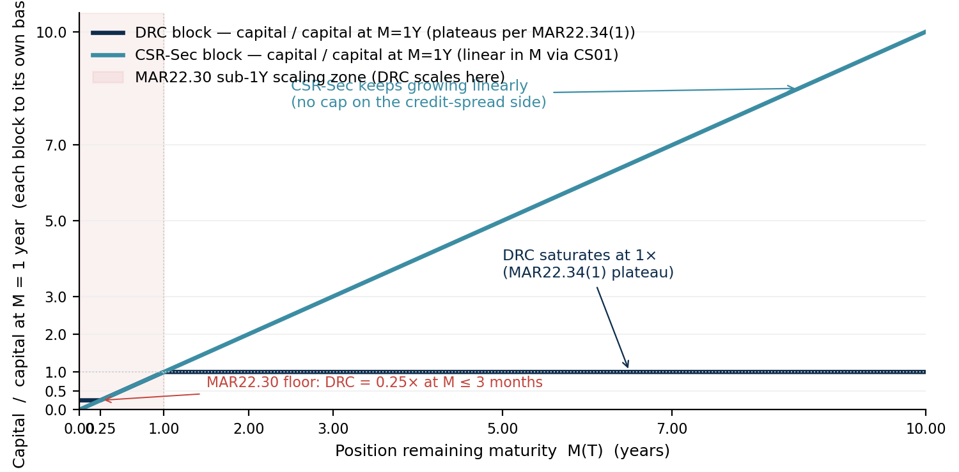
Exhibit 4. Each block's capital plotted as a multiple of its own M=1Y value. DRC saturates at 1× by MAR22.34(1) (the maturity component of the banking-book RW is pinned to one year). CSR-Sec keeps growing linearly via the CS01 ramp — at M=5Y it is roughly 5× its 1Y value within the block; at M=10Y roughly 10×. The MAR22.30 sub-1Y scaling zone is shaded.
7.1 What the shape table says — qualitative
Side by side, the two M(T) responses tell a clean story without any dollar value attached. The table below describes how each block behaves at five maturity points relative to its own 1Y baseline.
Remaining maturity | DRC capital — relative to its M=1Y value | CSR-Sec capital — relative to its M=1Y value
3 months | 0.25× (MAR22.30 floor at 3 months) | 0.25× (CS01 ≈ ModDur × MV × 1bp)
6 months | 0.50× (MAR22.30 sub-1Y scaling) | 0.50×
1 year | 1.00× (baseline) | 1.00× (baseline)
3 years | 1.00× (plateau) | ≈ 3×
5 years | 1.00× (plateau) | ≈ 5×
10 years | 1.00× (plateau) | ≈ 10×
Exhibit 5. Maturity sensitivity in each block, normalised to the block's own M=1Y value. DRC plateaus from 1Y; CSR-Sec grows linearly with duration. The columns deliberately use the SAME 'multiple of M=1Y' units so the shapes are comparable without comparing dollar magnitudes.
7.2 Ratio insight — where extra maturity *goes*
Take any two positions identical in every respect except maturity. The ratio of the LONGER position's total credit-risk capital to the SHORTER position's total credit-risk capital is almost entirely driven by the CSR-Sec block: the DRC component contributes zero to that ratio above 1Y, and only a sub-1Y reduction below 1Y. So the M(T) lever the framework gives you sits entirely on the CSR-Sec side.
- Extending a position from 1Y to 5Y does not change its DRC capital. It scales the position's CSR-Sec capital roughly by 5× (in the block's own units) via the longer-pillar CS01.
- Extending a position from 1Y to 10Y does not change its DRC capital. It scales the position's CSR-Sec capital roughly by 10× in the block's own units.
- Shortening a position to 6 months halves its DRC capital (MAR22.30 scaling factor 0.5×) AND halves its CSR-Sec capital. Both blocks respond to sub-1Y maturity reduction, by the same factor.
- Shortening a position to 3 months or less floors both blocks at 0.25× of their M=1Y value (MAR22.16/22.30 three-month floor for DRC; ModDur cannot drop below the legal floor for CSR-Sec).
ANCHORING THE INTUITION The chart and table above carry the regulator's M(T) design without any dollar number being shown. The pattern is the same regardless of the rating, asset class, bucket RW, or position size: maturity-driven additional capital flows through CSR-Sec, not DRC. Whether that additional capital is a few thousand dollars or several million on any particular position or portfolio depends on the bucket RW and the CS01 magnitude — but the SHAPE — DRC plateau, CSR-Sec linear ramp — is invariant.
8. Conclusions
- Two maturity rules, two jobs. The RW M(T) is pinned to 1Y inside the DRC RW formulas. The JTD scaling M(T) uses the position's real maturity, clipped to [0.25, 1.0], applied to gross JTD pre-netting. Different things.
- MAR22.34(1) is not a simplification, it is the *point*. Suppressing the banking-book maturity component in DRC is what avoids double-counting with the migration risk that CSR-Sec will charge for separately.
- Migration risk is real and material — it just lives in CSR-Sec. It flows through CS01 magnitudes at longer pillars and through MAR21 risk weights that embed historically-observed spread / migration shocks.
- 5Y AAA seniors are not under-capitalised in DRC; they are correctly capitalised in DRC and additionally capitalised in CSR-Sec. Treat DRC and CSR-Sec as two halves of one credit-capital answer.
- Practitioner heuristic. If anyone protests that the engine is wrong because a 5Y AAA gets the same DRC as a 1Y AAA, ask them to look at the CSR-Sec line for the same position. The story is in the other column of the SA capital workbook.

Appendix A — Engine Implementation Map
The table below maps each piece of the regulatory split to the exact module and function in the implementation. The engine is built so that the two M(T) flows are mechanically independent — they cannot be accidentally confused because they live in different files and consume different inputs.
Regulatory rule | Engine module | What it does
MAR22.34(1) overlay — M(T) = 1 inside the ERBA 1Y/5Y interpolation | drc_securitisation/sec_erba.py | Reads M_T_for_drc (= 1.0) from the loader frame; collapses the linear interpolation between the 1Y and 5Y CRE42 columns onto the 1Y column.
MAR22.34(1) overlay — M(T) = 1 in the CRE44.17 p-formula | drc_securitisation/sec_irba.py | Reads M_T_for_drc (= 1.0); feeds it into the E_p × M(T) term of the SEC-IRBA supervisory parameter.
MAR22.30 / 22.15-18 — gross-JTD scaling pre-netting | drc_securitisation/sec_loader.py and sec_engine.py | Loader computes M_T_position_years (real remaining maturity per position) and mat_scaling_factor = clip(M_T, 0.25, 1.0). step_9 in sec_engine.py multiplies MV_USD by mat_scaling_factor BEFORE summing across the tranche.
MAR21 — CSR-Sec delta capital | Capital pipeline (capital_main.py + weighted_sensitivities.py + intra_bucket.py + inter_bucket.py) | Consumes the per-position CSR-Sec CS01 at each FRTB tenor pillar from FRTB_Sensitivities.xlsx, applies the MAR21 bucket risk weights, aggregates intra- and inter-bucket.
Exhibit 6. Implementation map. The two DRC rules are in the DRC sub-tree; the CSR-Sec rule is in the SA capital pipeline. Two pipelines, one regulatory story.
Appendix B — Symbolic Formula Walk-Throughs
Each block's M(T) behaviour reduces to a small set of formulas. Below, each step is written symbolically so the regulatory logic is visible without committing to specific portfolio numbers. Apply the formulas to any position using the bank's actual MV, ModDur, bucket RW and scaling-floor / cap constants to compute that position's capital.
B1 DRC sec — single position, post-wrapper-stack
Symbol | Definition | Source
MV | Signed model market value of the position (= JTD per MAR22.27) | Sheet 2 MV_USD
M | Remaining maturity of the position, in years | Portfolio Maturity − asof
mat_scale = clip(M, 0.25, 1) | Per-position JTD scaling factor | MAR22.30 importing MAR22.15-18
scaled_JTD = MV × mat_scale | Gross JTD after MAR22.30 scaling, signed
RW = RW_table_1Y (post standard floor) | Risk weight read from CRE42 / 44 with the M(T) input pinned to 1Y | MAR22.34(1) overlay + CRE41.15 / 42.7 / 44.26 floor
DRC_capital = RW × 0.08 × |scaled_JTD| | Per-position default-risk capital | MAR22.33
Exhibit 7. The DRC chain. M appears only inside mat_scale (capped at 1.0); the RW formula sees a fixed 1Y maturity input regardless of M. So the M-sensitivity of DRC capital is entirely the MAR22.30 / 22.15-18 scaling factor.
B2 CSR-Sec delta — single position, single pillar
Symbol | Definition | Source
ModDur | Modified duration of the position (≈ M for a bullet tranche; smaller for amortising tranches) | Engine bump-and-reprice
CS01 = MV × ModDur × 0.0001 | Sensitivity to a 1bp parallel shift in credit spread, at the FRTB tenor pillar where the position's PV concentration sits | MAR21.20 / engine
RW = RW_bucket_per_pillar | MAR21 CSR-Sec Non-CTP bucket risk weight, calibrated on historical 1Y-horizon spread moves (including migration jumps) | MAR21.61 (or local equivalent table)
WS = RW × CS01 | Weighted sensitivity at the pillar | MAR21 SBM formula
K_b = sqrt(Σ WS² + ΣΣ ρ × WS_k × WS_l) over pillars in bucket | Bucket-level capital, intra-bucket aggregation | MAR21 SBM intra-bucket formula
CSR-Sec block = sqrt(Σ K_b² + ΣΣ γ × Sb_k × Sb_l) over buckets | Inter-bucket aggregation; the headline CSR-Sec charge | MAR21 SBM inter-bucket formula
Exhibit 8. The CSR-Sec delta chain. M enters via ModDur in CS01 and so scales the per-pillar WS roughly linearly with M. Aggregation is the SBM L2 sum with correlations; it does not undo the linear M dependence — longer-tenor positions carry more CSR-Sec capital, all else equal.
B3 Where M(T) shows up — comparative
Quantity | M(T) dependence | Cap / plateau
DRC RW | None (pinned to 1Y by MAR22.34(1)) | —
DRC scaling factor | linear for 0.25 ≤ M < 1 | Floored at 0.25; capped at 1.0 from M=1Y onward
DRC capital | = 0.25 × baseline at M ≤ 3m; linear up to M=1Y; FLAT for M ≥ 1Y | 1× of M=1Y value
CSR-Sec CS01 magnitude | ≈ linear in ModDur (which tracks M) | No cap
CSR-Sec capital | linear in M to first order; some non-linearity from intra-bucket correlations + amortising-tranche duration | No cap
Exhibit 9. Where M enters and where it stops. M-driven additional capital lives entirely in the CSR-Sec line above the 1Y horizon; below 1Y, both blocks scale down together via their respective linear-in-M factors.

References
The references below give the full source for every regulatory and internal claim in the note. They are consolidated at the end so the body reads as a continuous argument; the column ‘What it governs in this note’ ties each source back to where it is used.
Primary standards — Basel consolidated framework
Reference | Title and source | What it governs in this note
MAR22.27 | Standardised approach — default risk capital requirement; sec, non-CTP. Gross JTD definition for sec. | Statement that JTD for sec = position market value (LGD not applied to exposure).
MAR22.30 | Standardised approach — default risk capital requirement; sec, non-CTP. Offsetting and scaling of JTD positions. | Import of MAR22.15-18 offsetting + scaling rules into sec; basis for the gross-JTD scaling factor in the engine.
MAR22.15 — 22.18 | Standardised approach — default risk capital requirement; non-sec. Scaling of positions of less than one year. | Three-month floor / one-year cap for the per-position JTD scaling; applied by reference through MAR22.30.
MAR22.34(1) | Standardised approach — default risk capital requirement; sec, non-CTP. Risk weights and the maturity-component override. | The clause that fixes M(T) = 1 inside the banking-book RW formulas to avoid double-counting with CSR-Sec migration risk.
CRE40 — CRE44 | Securitisation framework — general provisions, SEC-SA, SEC-ERBA, SEC-IAA, SEC-IRBA. | The banking-book RW machinery that MAR22.34(1) imports with the M(T) = 1 modification. Sections 3, 5, 7 of this note.
MAR21 — chapters governing CSR-Sec (Non-CTP) | Standardised approach — sensitivities-based method. | The FRTB tenor pillars, bucket structure, CSR-Sec risk weights, and intra- / inter-bucket aggregation used in the CSR-Sec capital discussion in Section 6 and Appendix B.
Internal sources
Reference | Source | What it provides
drc_securitisation engine | FRTB SA / drc_securitisation / sec_loader.py, sec_erba.py, sec_irba.py, sec_engine.py. | Implementation of MAR22.34(1) (in sec_erba + sec_irba), MAR22.30 scaling (loader + step_9 of sec_engine).
SA capital pipeline | FRTB SA / capital_main.py, weighted_sensitivities.py, intra_bucket.py, inter_bucket.py. | CSR-Sec capital, consuming per-position CSR-Sec delta from FRTB_Sensitivities.xlsx (sensitivity-engine Sheet 1).
FRTB_Sensitivities.xlsx | Output of the sensitivity engine (Sensitivity v10). | Per-position CSR-Sec CS01 at FRTB tenor pillars used by the SA capital pipeline.
FRTB SA | Programme-level engineering documentation. | Per-tranche netting invariant, JTD = MV reading of MAR22.27, MAR22.34(1) overlay note, MAR22.30 / 22.15-18 scaling note — the same regulatory split described here, anchored at the code level.
Note on authority: the BIS chapters (MAR / CRE) are the authoritative sources. The internal pipelines and configuration workbooks implement those standards and are cited here for traceability of the engine implementation, not as independent authority.

